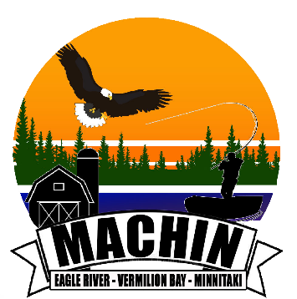

The Municipality of Machin Update
for the week of September .25th
, 2023 to September 29th, 2023.

Administration:
We will also be updating our website page.
We are working updating the calendar on our website.
Council Meeting on September 25th, 2023.

Public Works:
Public Works Meeting is Tuesday October 10th, 2023, at 6pm in Council Chambers at the Municipal Office. Agenda will be available on the Machin website: www.visitmachin.com.
Public Works will be working do some planning for projects coming up, so stay tune with our weekly post.
Helping get the arena ready for the season.
Planning Culvert change job at Bobby’s.
Thursday we will be repairing the Hydrant on Oak Street, we will need to close the road from Lane B to Pine Street.
The Bridge Study has been done we are just waiting on our report.

Water Plant:
Flushing Hydrant pumping and prepare for winter. Due to equipment failure we will have to continue at a later date.
Locating water main valves.
Thursday we will be repairing the Hydrant on Oak Street, we will need to close the road from Lane B to Pine Street.

Recreation:
Yoga with Sarah- Eagle River Recreation Centre- Tuesday September 26, 2023, from 6:30 pm to 7:30 pm. Everyone Welcome.

Council: Next Council Meeting is September 25th, 2023 at 6pm. Agenda will be available on the Machin website: www.visitmachin.com. Everyone welcome.

*Please be advise that this schedule is subject to change.

